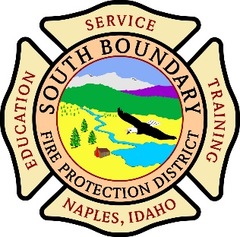 PUBLIC MEETING NOTICE
SOUTH BOUNDARY FIRE PROTECTION DISTRICTUNDAR FIRE P.O. Box 148 Naples, Idaho 83847BOUNDARY FIRE PRO(208)267-8052 www.southboundaryfire.comECTION DISTRICT
P.O. Box 148 Naples, Idaho 83847
(208)267-8052 www.southboundaryfire.com
AGENDA
Wednesday July 8th 2026 @ 6:00pm
Station #1 20 Stagecoach Rd. Naples, ID 83847

Pledge of Allegiance:

Approval of Minutes from June 10th 2026 meeting (Action Item)

Treasurers Report- Review Report for month ending June 2026. (Action item)

Fire Chief’s Report – Highlights calls, training, activities since last meeting.

Public Input Any input that is not on the Action Item list may not be voted
on, any items not on the Agenda may be discussed if deemed fit by Commissioners but will have to be posted to the next published meeting if action is required. Any public input will be limited to 3 minutes unless repeat testimony is requested by commissioners. When called upon by commissioners please state your full name and address.
Old Business
- Commissioner Sub District 2 Action Item
- CMWD Action Item
- Annual Wellness Exams Action Item
- Website, IT help Action Item

New Business
- EMT class Action Item
- Trash Pump Action Item
- Budget meeting Action Item
- Dry Hydrant Action Item

Executive Session Motion to go into Executive, if required pursuant to Idaho Code 74-206(1)a,b,c,d,e,f.
- To consider hiring a public officer, employee, staff member or individual agent, wherein the respective qualities are to be evaluated in order to fill a particular vacancy or need. This paragraph does not apply to filling a vacancy in an elective office or deliberations about staffing needs in general.
- To consider the evaluation, dismissal or disciplining of, or to hear complaints or charges brought against, a public officer, employee, staff member or individual agent, or public school student;
- To acquire an interest in real property not owned by a public agency;
- To consider records that are exempt from disclosure as provided in chapter 1, title 74 Idaho code;
- To consider preliminary negotiations involving matters of trade or commerce in which the governing body is in competition with governing bodies in other states or nations;
- To communicate with legal counsel for the public agency to discuss the legal ramifications of and legal options for pending litigation, or controversies not yet being litigated but imminently likely to be litigated. The mere presence of legal counsel at an executive session does not satisfy this requirement; (Action Item).
If you have special need or wish to add an item to the agenda please call (208) 267-8052

