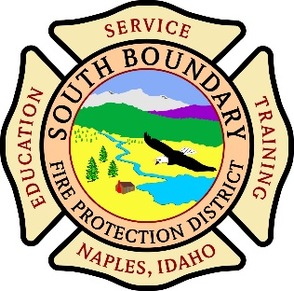
SOUTH BOUNDARY FIRE PROTECTION DISTRICTUNDAR FIRE P.O. Box 148 Naples, Idaho 83847BOUNDARY FIRE PRO(208)267-8052 www.southboundaryfire.comECTION DISTRICT
P.O. Box 148 Naples, Idaho 83847
(208)267-8052 www.southboundaryfire.com

Minutes of Meeting
Wednesday, February 11th , 2026
Attendees:

_______________X________________ Chairperson – Chad Kimball
_______________________________ Commissioner – Bruce Whittaker
_______________X________________ Commissioner- Brian Ohara
_______________X________________ Fire Chief – Michael Vandecoevering
_______________X________________ Treasurer- Debbie Youngwirth
_______________X________________ Secretary – Dustin Solt
Firefighter- Cori Vandecoevering

Also present- Raina and Earl Haworth

The meeting was called to order at 6:08 p.m.

Commissioner Kimball moved to approve the meeting minutes from January, 2026 Commissioner Ohara second. The motion passed unanimously.

Treasurer’s Report.
Attached. Discussed.

Commissioner Kimball moved to approve the Treasurer’s report for the month of January, 2026 Commissioner Ohara second. The motion passed unanimously.

Chief’s Report-
Attached/discussed

- All new door locks are put on door at all 3 stations
- Command 1 had a rock chip went to have filled and Accurate Northwest Autobody donated a replacement windshield
- Selkirk Fire is holding zoom meetings for Tomorrow's Leaders with different chiefs and training officers offering pointers. A few members have attended

Public Input: Cori Vandecoevering mentioned it might be worth bringing the status of the agreement with CMWD to the public so they have the history up to this point and the agreement will be signed in the weeks to come. Commissioners agreed and planned a public statement to be approved.

Old Business-

-CMWD- we have not received the updated agreement from the special meeting at Paradise Valley Station. We were told it could be a few weeks for it to be drafted and sent for commissioners to sign.
-VFIS Insurance documents were discussed and signed

New Business-

- Haworth property annexation. Documents were discussed, approved and signed.
-Brush truck: slip tank is off and will be sent to auction next week. Price variation was discussed.
-New rescue helmets: Chief Vandecoevering would like to have a helmet for each personnel at an incident.
-Clear Water Academy: They do a fire academy every year. Coming up April 9th 10th and 11th. Sending members was discussed and approved

Meeting was adjourned at 6:34

